Monster Maker Pi Toolbox Importer

Release 1, May 2020

Contents

Release Version Notes and Log 2

Pi Toolbox Exports 3

Controls 3

Utilities 4

Filtering 4

Check Units 4

Use Altitude 5

Distance Calculation 5

Zeroing 5

Latched Settings 6

# Release Version Notes and Log

May 9, 2020

* Initial release and documentation

# Pi Toolbox Exports

To make use of all of the features, the following channels need to be exported:

* Lap Number
* Lap Time
* Engine RPM
* Accel X
* Accel Y
* Damper Travel FL,FR,RL,RR
* Steer wheel angle
* Throttle position
* Speed

Optional channels include

* Air speed
* Accel Z
* Loads FL,FR,RL,RR
* Altitude

Note, these are the standard ChassisSim monster file requirements, except for the lap number and time which are needed to use the lap picker function. If these channels are not present, the program will assume that you have already done the appending. The export also must be at 50 Hz to create a monster file!

# Controls

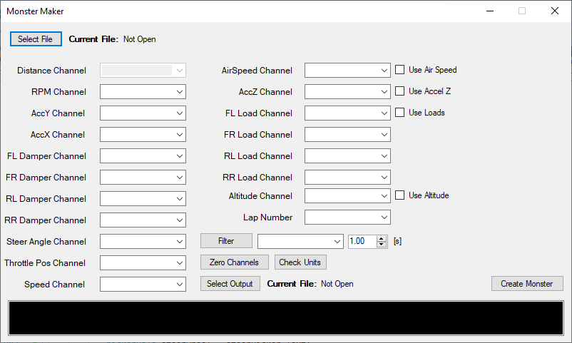

The Pi Import tool for ChassisSim is used via the interface above. After selecting a file using the “select file” dialog, the channel lists will be populated with the names of the channels in the import file. Simply select the channels that you would like to use for the monster file and then you are good to go!

The following are the base controls:

|  |  |
| --- | --- |
| Select File | Select the Pi Toolbox exported ASCII file to be processed into a monster file. If the file doesn’t appear to be a Pi Toolbox file, it will display a message saying such. Note: occasionally a file edited in excel will be unable to be parsed, if this is the case re-export the file from Toolbox. |
| Select Output | Points to where the file should be saved and gives the option of naming it |
| Create Monster | The button that hits go – if all is correct, the monster file created message will be displayed in addition to the lap time in seconds as a test to see if the lap time seems correct to you. |
| Use XXX | The toggle to use the air speed, Z axis acceleration, or loads. Altitude enables another exported file covered in more detail further down. |

# Utilities

## Filtering

The filtering implemented is a moving average filter in the duration specified. The channel that is zero’d is then added to the channel list again with the filter amount appended to the end. If multiple filters of the same size are selected, it will be added in to the channel list with a (1) added after it.

### Usage

In order to use the filtering tool to filter an Accel Y Channel after loading channels in:

1. Use the filter selector to choose your channel to be filtered

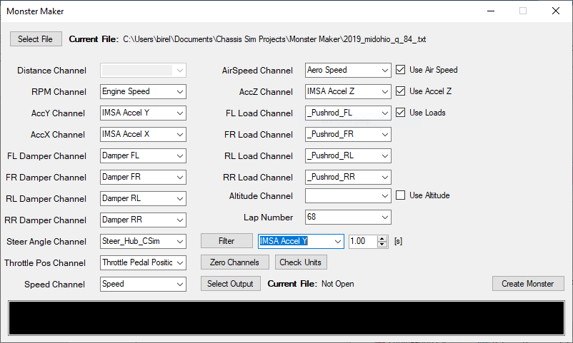

1. Use the moving average filter time window to select the moving average time. This functions similarly to a Pi Toolbox moving average filter in notation. For this example we’ll use a 0.2 second filter:

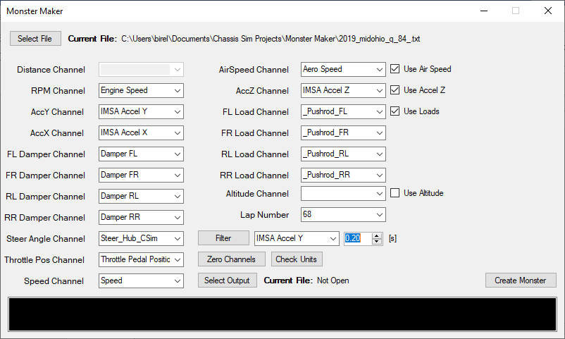

1. Click “Filter” and the new channel will appear in the dropdown menu of channels to be used

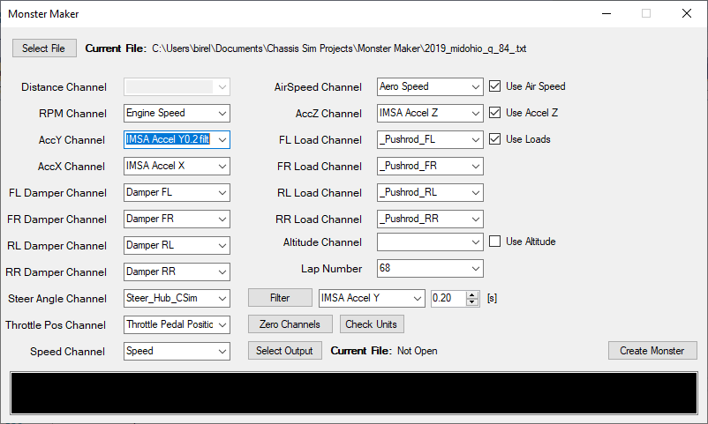

You are now using a filtered Acceleration Y Channel

## Check Units

Check units scans the designated import units from Pi Toolbox to make sure that they align with what ChassisSim is expecting. For example, if you have the Z axis accelerometer set to $\frac{m}{s^{2}}$ instead of G, it will alert you to the file.

### Usage

Select the channels as if you were going to generate the file and click “Check Units”. No changes to your units will be done, but it will alert you if an import unit doesn’t match what is expected.

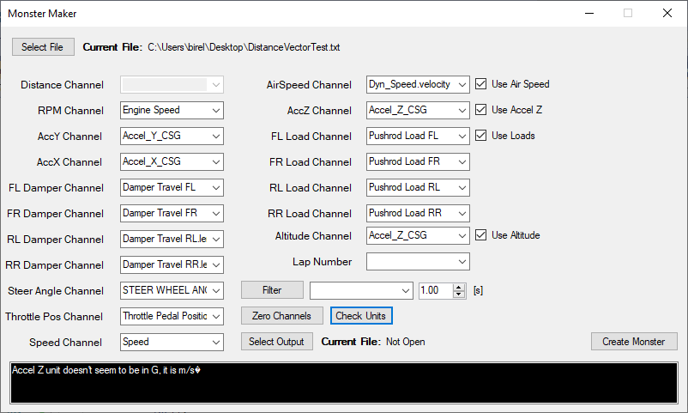

## Use Altitude

To also create an altitude file in addition to your monster file, check the use altitude box. A new file will be created in the same directory with “-alt” appended to the file.

## Distance Calculation

In order to avoid the issues with the way that Pi Toolbox can export distance and the issues within that, the utility calculates distance for each output range based on the speed input.

## Zeroing

In the even that zeroing was not performed in Pi Toolbox, a graphic zeroing tool has been implemented into the software. This allows us to zoom in to the entire data range and zero at certain points

### Usage

To pick a location to zero in the data, use the zero button. A new window opens with a sample graph and a selection of multiple channels.

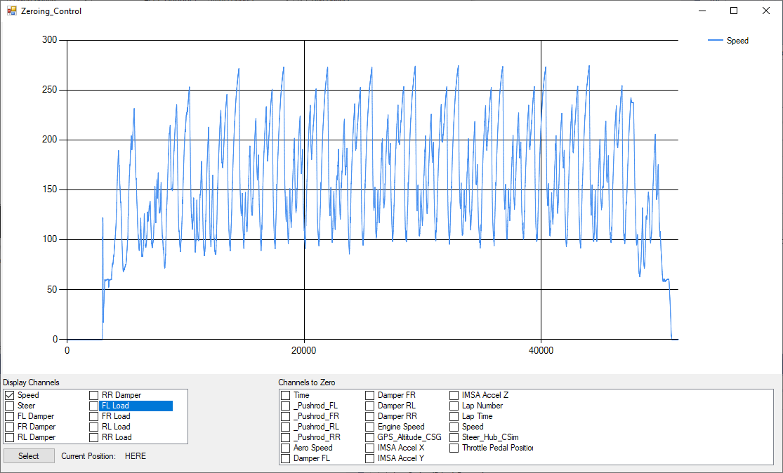

The left box will display the various channels that can be displayed, where the right box has the full channel list where you can select to be zero’d. By clicking and dragging you can zoom in on a smaller area.

The current cursor position in samples will be displayed next to the select button.

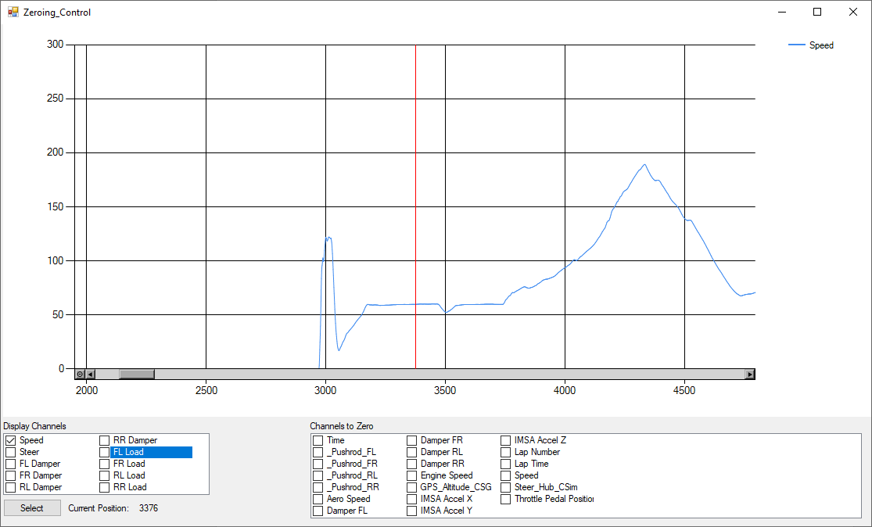

The red bar is the position on the axis.

Upon pressing select, the channels that are to be zero’d will be added to the list at the sample listed.

Note: The plot tool is not very good and is currently being worked on. Sometimes plot auto bounds changes incorrectly, sometimes it zooms when you feel like it should be sliding. This isn’t a great tool but is what is baked into .Net and is looked at being changed further.

## Latched Settings

A file is created to maintain settings for a data logger utilizing the name “userSettings.ini”. This is what allows for the previous settings to be repopulated when loading another file from the same export car. Multiple cars can be saved, and they’re saved by the car name exported out of Pi Toolbox. If you change the logger or name of logger, it will not repopulate your settings. This was implemented for the sake of saving time upon working through multiple files.